Diagram | Size | Food Stuff | Kcals | Portions
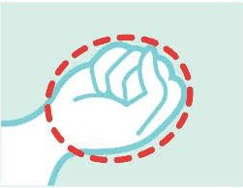 | Fist  1 cup, 150g,  6 oz | Rice, Pasta  Fruit  Veggie | 200  75  40 | NO MORE THAN  2-3 per day  2-3 per day  5+ per day
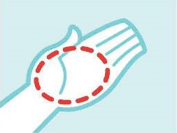 | Palm  85g  3 oz | Meat,  Fish  Poultry | 160  160  160 | 1-2 per day  1-2 per day  1-2 per day
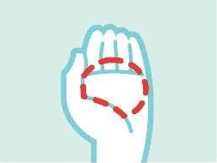 | Handful  25gs  1 oz | Nuts  raisins | 170  85 | 1-2 per day  1-2 per day
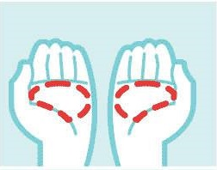 | 2 Handfuls  50g  2oz | Crisps  Popcorn  pretzels | 150  150  150 | < 1 per week  <1 per week  <1 per week
 | Thumb  30g  1oz | Hard Cheese  Peanut butter | 100  170 | 1 per day  1 per day
 | Thumb tip  1 teaspoon  15ml | Olive oil  Mayonnaise, Butter  sugar | 40  35  35  15 | 1 per day  1 per day  1 per day  1 per day
Devised by Annie Edmunds from First taste Nutrition
Handy Hand Guide

